2015-2016 Beebe High School Quiz Bowl Team:
Best of luck to our High School Quiz Bowl team!!! They will compete at the State Quiz Bowl Tournament, April 9th at Maumelle High School.

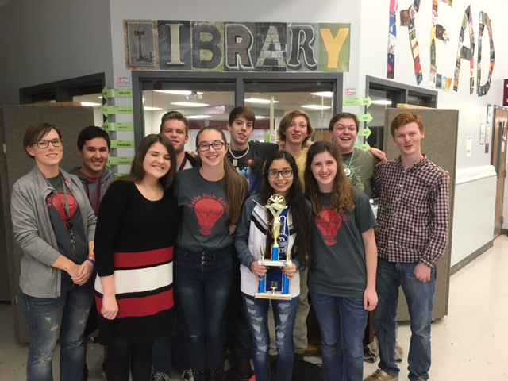

Congratulations to the 2015-2016 Beebe High School Quiz Bowl Team. The team placed 2nd in the Regional Quiz Bowl Tournament.
Back Row:
Charlie Fancyboy, Garret Gardenhire, Parker Pruitt, Bo Copeland, Colton Hunter
Front Row:
Casey Woods (Sponsor), Sarah Peterson, Mary Claire Durr, Mezthly Pena, Jaycee Hall

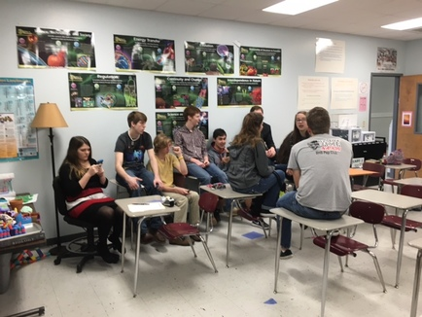

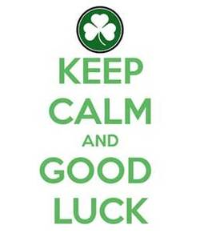

Way to go!!! Congratulations to Parker Pruitt and Colton
Hunter for making the 2015-2016 QB All Star Team.

