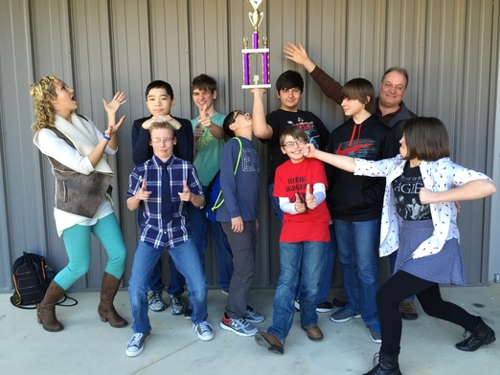
Sponsors:
Lydia Brumfield, 5th-8th GT
GT Specialist
Greg Stinnett, 7th Grade Pre-AP
English

Congratulations to our Jr. High Quiz Bowl team for winning 1st place in
the 5A Regional Quiz Bowl Tournament!
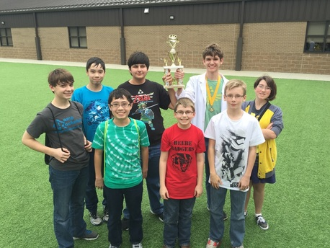

Beebe Jr. High Quiz Bowl Team placed 3rd in the 5A State Quiz Bowl Tournament.
Congratulations!!!
Left to Right
Back Row: James Berkheimer, Erik Stinnett, Levi Lewis, Ryan Swafford, Emily Humphrey
Front Row: Kevin Stinnett, Jared Humphrey, Logan Babel

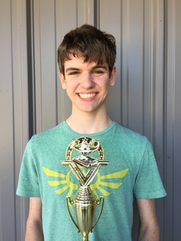

Congratulations to Ryan Swafford (9th grade) who earned MVP and All-Star Awards!!
Way to go Ryan!!!!

