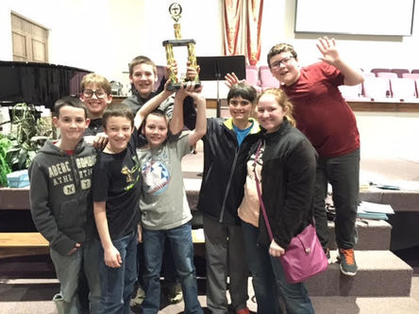
Congratulations of the 2015-2016 Middle School Quiz Bowl Team. Our Middle School Team won 1st place at the Wilbur D. Mills Cooperative Quiz Bowl Tournament.
Congratulations and way to go!!!!

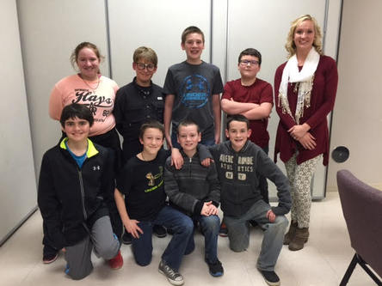
Picture from left to right:
Back row - Karlie Holland, Christian Cummings, Ethan
Godwin, Ethan McNully
Front row - Shayde Harris, Ethan Abernathy, Jadyn Cargile,
Carson Brown
Sponsor -- Lydia Brumfield, 5th-8th GT Specialist
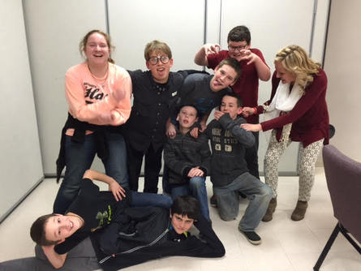

YAY!!!!!

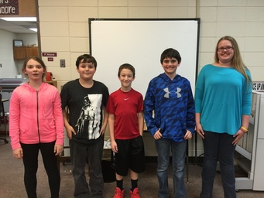
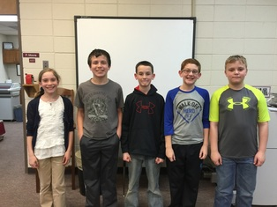
Gillian Howard, Trey Kirkland, Carson Brown, Austin Patrom
Daniel Fitch Sarah Berkheimer, Landen McCullough, Ethan Abernathy,
Shayde Harris, Harley Walls

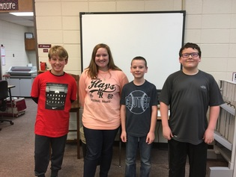 Christian Cummings, Karlie Holland, Jadyn Cargile, Ethan McNully

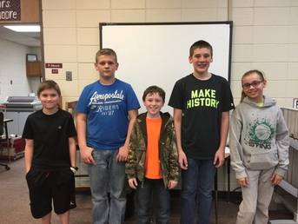 T.C. Harrison, Kohlman Matos, Brady McMullen, Ethan Godwin, Joshlyn Clark

